[--->Step 1: I navigate to page "Hiring Login"[FAILED]<---]
  
[--->Failed Reason:
org.openqa.selenium.TimeoutException: Expected condition failed: waiting for url to contain "/hiring/login". Current url: "https://www.resume-library.com/403.html" (tried for 50 second(s) with 500 milliseconds interval)
Build info: version: '4.6.0', revision: '79f1c02ae20'
System info: os.name: 'Mac OS X', os.arch: 'aarch64', os.version: '12.6.1', java.version: '19.0.1'
Driver info: org.openqa.selenium.remote.RemoteWebDriver
Capabilities {acceptInsecureCerts: false, browserName: chrome, browserVersion: 100.0.4896.127, chrome: {chromedriverVersion: 100.0.4896.60 (6a5d10861ce8..., userDataDir: C:\Users\ltuser\AppData\Loc...}, goog:chromeOptions: {debuggerAddress: localhost:50299}, goog:loggingPrefs: {browser: ALL}, networkConnectionEnabled: false, pageLoadStrategy: normal, performance: false, platformName: WINDOWS, proxy: Proxy(), se:cdpVersion: 100.0.4896.127, setWindowRect: true, strictFileInteractability: false, timeouts: {implicit: 0, pageLoad: 300000, script: 30000}, unhandledPromptBehavior: dismiss and notify, video: true, webauthn:extension:credBlob: true, webauthn:extension:largeBlob: true, webauthn:virtualAuthenticators: true}
Session ID: 7619ccde18c89a50a7bbf7ef02e9640b
at org.openqa.selenium.support.ui.WebDriverWait.timeoutException(WebDriverWait.java:87)
at org.openqa.selenium.support.ui.FluentWait.until(FluentWait.java:231)
at com.resumelibrary.utilities.Utility.webDriverWaitContainsUrl(Utility.java:159)
at com.resumelibrary.cucumber.stepdefinitions.web.candidate.Others.iNavigateToPage(Others.java:128)
at ✽.I navigate to page "Hiring Login"(file:///Users/surendran/Downloads/CVL-WEB-REPO-master2_BasicRunner/./src/test/java/resources/featurefiles/web/client/login/Login.feature:491)
<---]  
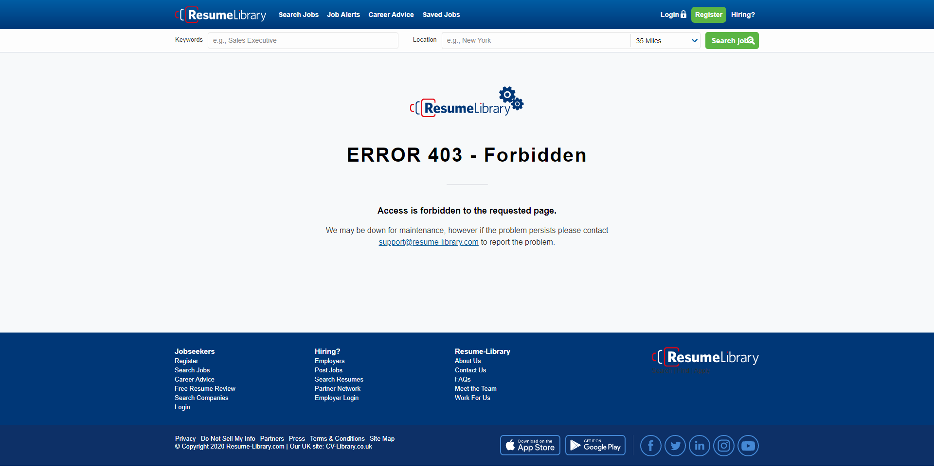

[--->Step 2: I click on "Jobseeker login"[SKIPPED]<---]

[--->Step 3: I should be able to see in browser URL "Login"[SKIPPED]<---]

[--->Step 4: I should see button "Login as Jobseeker"[SKIPPED]<---]

[--->Step 5: I should see text "Create a jobseeker account"[SKIPPED]<---]

[--->Step 6: I click on "Jobseeker login"[SKIPPED]<---]

[--->Step 7: I should be able to see in browser URL "Login"[SKIPPED]<---]

[--->Step 8: I should see button "Login as Jobseeker"[SKIPPED]<---]

[--->Step 9: I should see text "Create a jobseeker account"[SKIPPED]<---]

[--->Step 10: I navigate to page "Hiring Login"[FAILED]<---]
  
[--->Failed Reason:
org.openqa.selenium.NoSuchSessionException: Session ID is null. Using WebDriver after calling quit()?
Build info: version: '4.6.0', revision: '79f1c02ae20'
System info: os.name: 'Mac OS X', os.arch: 'aarch64', os.version: '12.6.1', java.version: '19.0.1'
Driver info: org.openqa.selenium.remote.RemoteWebDriver
Command: [null, get {url=https://www-master.ci.resume-library.com/hiring/login}]
Capabilities {acceptInsecureCerts: false, browserName: chrome, browserVersion: 100.0.4896.127, chrome: {chromedriverVersion: 100.0.4896.60 (6a5d10861ce8..., userDataDir: C:\Users\ltuser\AppData\Loc...}, goog:chromeOptions: {debuggerAddress: localhost:54992}, goog:loggingPrefs: {browser: ALL}, networkConnectionEnabled: false, pageLoadStrategy: normal, performance: false, platformName: WINDOWS, proxy: Proxy(), se:cdpVersion: 100.0.4896.127, setWindowRect: true, strictFileInteractability: false, timeouts: {implicit: 0, pageLoad: 300000, script: 30000}, unhandledPromptBehavior: dismiss and notify, video: true, webauthn:extension:credBlob: true, webauthn:extension:largeBlob: true, webauthn:virtualAuthenticators: true}
at org.openqa.selenium.remote.HttpCommandExecutor.execute(HttpCommandExecutor.java:145)
at org.openqa.selenium.remote.TracedCommandExecutor.execute(TracedCommandExecutor.java:51)
at org.openqa.selenium.remote.RemoteWebDriver.execute(RemoteWebDriver.java:541)
at org.openqa.selenium.remote.RemoteWebDriver.get(RemoteWebDriver.java:310)
at com.resumelibrary.utilities.Utility.getDriverWithUrl(Utility.java:49)
at com.resumelibrary.cucumber.stepdefinitions.web.candidate.Others.iNavigateToPage(Others.java:121)
at ✽.I navigate to page "Hiring Login"(file:///Users/surendran/Downloads/CVL-WEB-REPO-master2_BasicRunner/./src/test/java/resources/featurefiles/web/client/login/Login.feature:524)
<---]

[--->Step 11: I click on "Jobseeker login"[SKIPPED]<---]

[--->Step 12: I should be able to see in browser URL "Login"[SKIPPED]<---]

[--->Step 13: I should see button "Login as Jobseeker"[SKIPPED]<---]

[--->Step 14: I should see text "Create a jobseeker account"[SKIPPED]<---]